PipeLine Graphs 6-3
Introduction 6-3
PipeLine Graphs 6-3
Stock Status Graph 6-3
Creating a Stock Status Graph 6-4
Products and Types 6-6
Excluding Planned Shipments 6-6
Consumption Graph 6-7
Creating a Consumption Graph 6-7
Products and Types 6-8
Trend Analysis Graph 6-10
Creating a Trend Analysis Graph 6-11
Couple-Years of Protection (CYP) Graph 6-13
Creating the CYP Graph 6-13
Exporting the CYP Graph 6-16
Previewing and Printing PipeLine Graphs 6-17
Previewing a Graph 6-17
Printing a Graph 6-19
Creating PDF of a Graph 6-19

Pipeline graphs
Figure 6-1—Stock Status screen 6-5
Figure 6-2—Display options 6-6
Figure 6-3—Display options 6-6
Figure 6-4—Select Suppliers to Exclude box 6-7
Figure 6-5—Consumption screen 6-8
Figure 6-6—Display options 6-8
Figure 6-7— Display options 6-9
Figure 6-8—Trend Analysis screen 6-12
Figure 6-9—Calculation Types 6-12
Figure 6-10—Couple-Years of Protection CYP screen 6-15
Figure 6-11—Export CYP Data window 6-17

PipeLine Graphs

Introduction
This section lists the PipeLine graphs and provides a brief description of each. Also included is guidance on how to use the output from the graphs for pipeline monitoring and procurement planning.

PipeLine Graphs
PipeLine can create the following graphs.

Stock Status
Monthly or quarterly bar chart showing the actual and projected months of stock for a product or type, compared to the program’s maximum and minimum levels.

Consumption
Monthly or quarterly bar chart showing actual and forecast consumption by product or type.

Trend Analysis
Monthly or quarterly bar chart showing a trend analysis of a selected set of consumption data for a particular product.

Couple-Years of Protection (CYP)
Monthly or quarterly bar chart showing actual and forecasted couple-years of protection (CYP) by product or method.

Stock Status Graph
 | The couple-years of protection (CYP) graph can only be created for products that belong to a Method with a CYP factor.
The Stock Status graph provides a quick view of your program’s actual and forecast stock levels. It creates a bar chart, by month or quarter, showing months of stock for a selected product or type that is expected to be available in your logistics system at the end of the month or quarter. If you enter the maximum and minimum desired stock levels for a product, these are displayed and compared to estimated stock balances.

When you talk with policymakers, donors, and other suppliers, use this graph to show an overview of your stock situation. If the graph shows forecast stock levels that are far below your minimum, or if it projects that you will stock out of the product or type, you should begin plans to obtain additional supplies. You may also need to review your consumption forecast for accuracy.

If the graph shows actual stock levels that are far below minimum or above maximum, review past procurement plans and your inventory control procedures to determine why stock levels are out of balance. Better inventory control procedures, or more accurate stock data, may prevent future problems.

Creating a Stock Status Graph
The Stock Status graph is based on the last product or method that was updated or displayed. The default time period is five years, which includes the current year, previous two years, and following two years. Using stock data, you can create a stock status graph for any product in your program.

The following explains how to create a Stock Status graph.
 | The procedure for creating a Stock Status graph is the same regardless of the product you choose.

From the Tree View—

- Click on the Stock Status Tree View option (under Graphs) to display the Stock Status screen (see Figure 6-1).
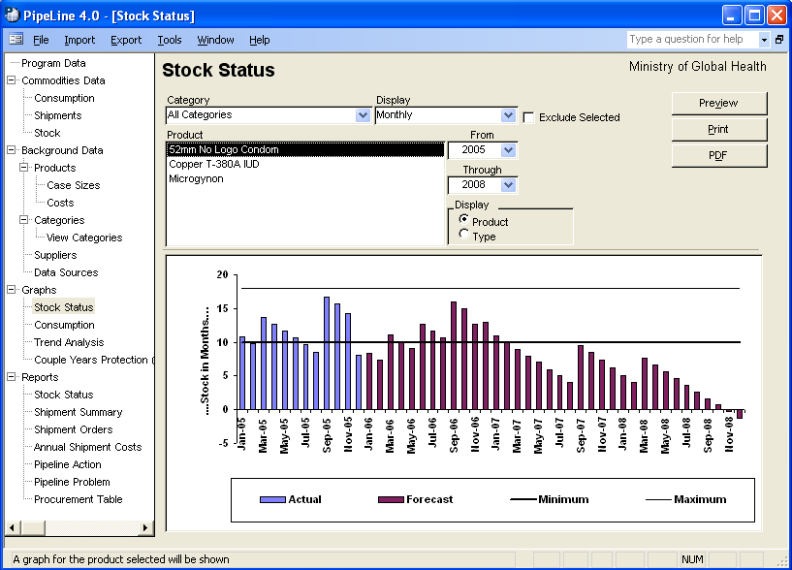
Figure 6-1—Stock Status screen

- Click on the arrow next to the Category field, and select a category from the pull-down menu.
Or, select All Categories from the Category pull-down menu to access all the products in your program.

The Display field enables you to create a graph that displays stock data on a monthly or quarterly basis.

- Click on the arrow next to the Display field, and select Monthly to display the data by month or Quarterly to display the data by quarter.

Products and Types
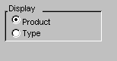
Figure 6-2—Display options
Using PipeLine, you have the option of selecting items by Product or Type (see Figure 6-2).

The Product option is selected by default. To display
data by Type, which is a list of Types filtered by Category,—

- Click on the Type option.
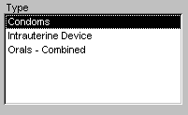
Figure 6-3—Display options
PipeLine changes the label of the Product box to Type, and it displays all Types associated with the selected category (see Figure 6-3).

The Product/Type box shows the product(s) you can select to create a stock status graph.

- Click on the Product or Type you need to create the graph.

The From and Through fields let you determine
the span of time the graph will cover.

- Click on the arrow next to the From field, and select the starting year for the report period.

- Click on the arrow next to the Through field, and select the last year of the report period.

Excluding Planned Shipments
The Exclude Selected field enables you to exclude planned shipments from the Stock Status graph by letting you exclude the suppliers of these shipments from the output.

- Click on the Exclude Selected field.

The Select Suppliers to Exclude box opens, displaying the suppliers of your products (see Figure 6-4).
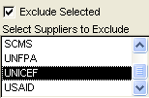
Figure 6-4—Select Suppliers to Exclude box

- Click on the suppliers whose planned shipments you want to exclude from the graph.

To select more than one supplier—

- Hold down the Control key (<Ctrl>), and click on each supplier you want excluded from the graph.

See page 21 for information on previewing, printing, and creating a PDF of the Stock Status graph.

Consumption Graph
The Consumption graph shows actual and forecast consumption (quantity dispensed to clients) of a selected product/type. This graph can display monthly or quarterly consumption.

Use this graph when you discuss the reasonableness and reliability of your consumption forecasts. If the pattern or quantity of the forecast consumption is different from the actual consumption, ask why. If future growth is projected to be more rapid than past growth, have good justification based on program plans and evidence that other necessary resources (staff, facilities, money) will be available.

Creating a Consumption Graph
The graph is based on the last product or method and the period updated or displayed. The default period is five years (the previous two years, current year, and following two years). A graph can be created for a specific product or type.

From the Tree View—

- Click on the Consumption Tree View option.

The Consumption Graph screen is displayed (see Figure 6-5).

- Click on the arrow next to the Category field, and select a category from the pull-down menu.
Or, select All Categories from the Category pull-down menu to access all the products in your program.

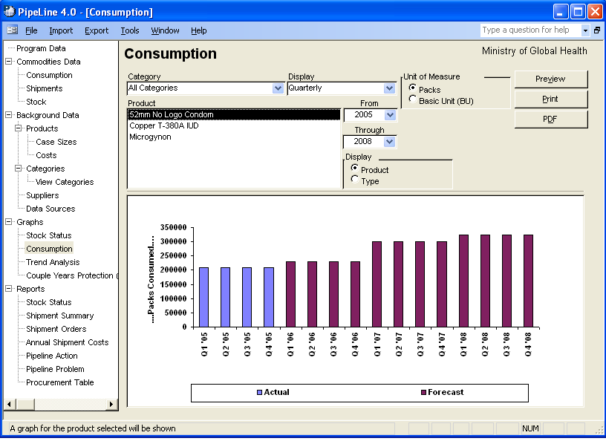
Figure 6-5—Consumption screen
The Display field lets you create a graph that displays stock data on a monthly or quarterly basis.

3. Click on the arrow next to the Display field, and select Monthly to display the data by month or Quarterly to display the data by quarter.

Products and Types
Figure 6-6—Display options Using PipeLine, you can select items by Product or Type (see Figure 6-6).

The Product option is selected by default. To display data by Type, which is a list of Types filtered by Category,—

- Click on the Type option.
Figure 6-7— Display options
PipeLine changes the label of the Product box to Type and displays all Types associated with the selected category (see Figure 6-7).

The Product/Type box shows the products that you can select to create a stock status graph.

- Click on the Product or Type you need to create the graph.

The From and Through fields enable you to determine the span of time the graph will cover.

- Click on the arrow next to the From field, and select the starting year of the report period.

- Click on the arrow next to the Through field, and select the last year of the report period.

The Unit of Measure area (see figure 6-10) lets you select whether Packs or Basic Units are displayed.
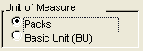
Figure 6-10—Unit of Measure Values
- Click on the Packs field to create a report based on packs.

Click on the Basic Unit (BU) field to create a report based on the basic units.

See page 21 for information on previewing, printing, and creating a PDF of the Consumption graph.

Trend Analysis Graph
The Trend Analysis Tree View option graphs a straight line trend through actual consumption data and calculates the quantity on the trend line that corresponds to each month, quarter, and year up to ten years from the first trend year. The trend is based on the Semi-Average or Linear Regression calculation method.

Semi-Average
Divides the actual consumption data into the first and second half, and calculates the average of each. If the series is an odd number, the middle number is included in both averages. The trend is calculated to intercept these averages.

Linear Regression
Is a statistical formula applied to the actual consumption data series to minimize the distance of the data series points from the trend.

The trend is calculated based on actual consumption by month, as reported in the Stock Status report. However, a report showing the data by quarter may be more useful. Use the Monthly display if you entered monthly consumption data, and if you want to see the seasonality or variation of the data compared to the straight trend.

The first year of the report must have actual consumption records because the trend is calculated based on actual consumption records in the first year and subsequent actual consumption records up to ten years (if they exist). The trend is calculated and displayed for a period up to ten calendar years from the first year.

Use this report to compare your forecast to the trend of actual data, or use it as a starting point for or analysis of, a new forecast.

Creating a Trend Analysis Graph
This graph shows consumption data in PipeLine and the trend of the actual consumption data. Forecast consumption data are displayed in a bar graph that is not in the trend calculation.

From the Tree View—

- Click on the Trend Analysis Tree View option.

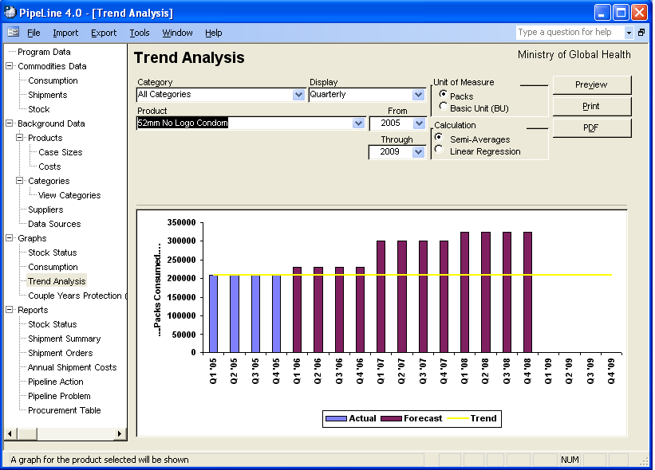
Figure 6-8—Trend Analysis screen The Trend Analysis screen is displayed (see Figure 6-8).

- Click on the arrow next to the Category field, and select a category from the pull-down menu.
Or, select All Categories from the Category pull-down menu to access all the products in your program.

- Click on the arrow next to the Product field, and select a product from the pull-down menu.

- Click on the arrow next to the Display field, and select Monthly to display the data by month or Quarterly to display the data by quarter.

- Click on the arrow next to the From field, and select the starting year of the report period from the pull-down menu.

- Click on the arrow next to the Through field, and
select the last year of the report period from the
pull-down menu.
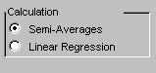
Figure 6-9—Calculation Types

The Calculation area of the Consumption Trend Analysis screen (see Figure 6-9) lets you create a trend graph based on semi-averages or linear regression.

- Click on the Semi-Averages field (under Calculation) to create a report based on semi-averages.
Click on the Linear Regression field (under Calculation) to create a report based on linear regression.

The Unit of Measure area (see figure 6-10) lets you select whether Packs or Basic Units are displayed.
Figure 6-10—Unit of Measure Values
- Click on the Packs field to create a report based on packs.

Click on the Basic Unit.(BU) field to create a report based on the basic units.

See page 21 for information on previewing, printing, and creating a PDF of the Trend Analysis graph.

Couple-Years of Protection (CYP) Graph
The couple-years of protection (CYP) graph uses the conversion factors in the Categories table of the Background Data menu to convert consumption data for selected product(s) or method(s) to CYP units.
 | The couple-years of protection (CYP) graph can only be created for products that belong to a Method with a CYP factor.
The graph lets you measure and compare the extent of coverage provided across methods. For example, you will need approximately 120 condoms to protect one couple for one year but you will need only four units of Depo-Provera. The coverage you achieve from 120 condoms consumed is comparable to four Depo-Provera injections.

You can compare coverage achievement over time despite changes in the method mix. You may dispense fewer units of contraceptives in the future, but if these units have higher CYP factors, you could provide greater coverage.

Use this graph to evaluate and monitor program coverage and achievement. (See the FPPMES User’s Manual for more information.)

Creating the CYP Graph
This graph is based on the percentage of one year during which each counted unit of a product/method provides protection from pregnancy.

For example: Four Depo-Provera injections are needed to provide one year of protection. Therefore, a single injection provides protection for .25 of a year (three months).

The number of CYPs is calculated by multiplying products/methods dispensed by the appropriate conversion factor. If 100 Depo-Provera injections were dispensed during a quarter, then 25 CYPs were generated (100 ×.25). To create a CYP graph—

From the Tree View—

- Click on the Couple-Years of Protection (CYP) Tree View option.

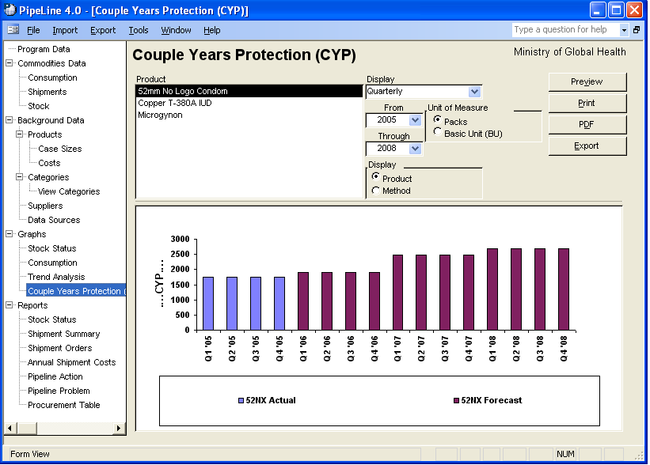
Figure 6-10—Couple-Years of Protection CYP screen The Couple-Years of Protection (CYP) screen is displayed (see Figure 6-10).

The Product option is selected by default. To display data by Method—

- Click on the Method option.
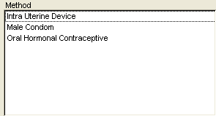
Figure 6-11— Display options
PipeLine changes the label of the Product box to Method and displays all Methods associated with the selected category (see 6-11).

The Product/Method box shows which product you can select to create a stock status graph.

- Select the Product(s)/Method(s) you want included on the graph.

- Click on the arrow next to the Display field, and select Monthly to display the data by month or Quarterly to display the data by quarter.

- Click on the arrow next to the From field, and select the starting year of the report period.

- Click on the arrow next to the Through field, and select the last year of the report period.

The Unit of Measure area (see figure 6-11) lets you select whether Packs or Basic Units are displayed.

- Click on the Packs field to create a report based on packs.
Figure 6-12—Unit of Measure Values
Click on the Basic Unit (BU) field to create a report based on the basic units.

See page 21 for information on previewing, printing, and creating a PDF of the CYP graph.

Exporting the CYP Graph
Use the Export button to export the data of a CYP graph.

With the Couple-Years of Protection (CYP) screen displayed—

- Create a CYP graph for a selected product/method.

See Creating the CYP Graph beginning on page 16.

- Click on the Export button.

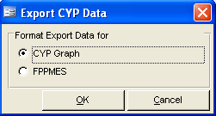
Figure 6-13—Export CYP Data windowPipeLine displays the Export CYP Data window (see Figure 6-13). Use the options in this window to arrange the data in a Microsoft Office Excel spreadsheet.

CYP Graph
Incorporates the CYP factors into the consumption totals for use in ad hoc reports and graphs.

FPPMES
Arranges the data for use with the Family Planning Program Monitoring and
Evaluation System.

The default is CYP Graph.

- Click on the OK button to accept the default.
Or, Click on FPPMES, and click on the OK button.

PipeLine displays the Output window with the default file name (based on your selection) displayed in the File Name field.

- Click on the OK button to accept the default.
Or, click on the File Name field, and type the export file’s name.

- Click on the OK button to save the data in the selected format.

Previewing, Printing, and Creating a PDF of PipeLine Graphs
The procedure for previewing and printing PipeLine graphs is the same regardless of the type of graph you create.

Previewing a Graph
A compact version of the graph (regardless of the type you create) is continually displayed on the lower half of your screen. To preview the entire graph—

- Click on the Preview button.

The selected graph is displayed onscreen for you to review. If you are satisfied with the data as presented, you can print the graph from the preview screen.

- Click on the print icon to send the graph to your default printer.

- Click on the close icon to return to the previous screen.

Printing a Graph
To send a graph directly to your default printer, without previewing it—

- Click on the Print button.

Creating a PDF of a Graph
To create a PDF of a graph without previewing it—

- Click on the PDF button.

To create a PDF of a graph from the preview of the graph—

- Click on the Preview button.

- Click on the PDF icon to create a PDF of the graph.
!! | To create a PDF, you must first choose a PDF writer. For more information on choosing a PDF writer, see page A-6.

